17820 SE 109th Ave #102 Summerfield, FL 34491 (352) 347-3338
1800 SE 17th St #601 Ocala, FL 34471 (352) 351-0375
Email: contact@liveoakfootankle.com
Website: www.liveoakfootankle.com

Proper Walker Technique
Types of Devices:

Standard Walker:
This is the classic walker without wheels. All four legs contact the ground at all times. It must be lifted up in order to advance it forward. It is the most stable of the devices and is the only device suitable for patients instructed to maintain non-weightbearing on one limb (ie. Post-surgery, trauma, wound-related, etc.). Accessories such as tennis balls, or glides can be added to allow for easier advancement of the walker, though stability is sacrificed by doing so.

Rollator (Wheeled Walker):
As the name suggests, a Rollator is a walker with (usually) four wheels and brakes. They may also have a seat integrated into them. These are the most liberating devices, but also the least stable. They are useful for those with arm/upper body weakness as well as for those that simply need to periodically stop and rest while walking related to respiratory issues such as shortness of breath. These devices should not be used to support the bodies weight.

Hybrid Devices:
These are basically a standard walker that have two wheels in the front to make advancement of the device easier.

How Tall Should the Walker Be?
--All four legs should be equal length
--When standing straight, the top of the walker should correspond to your wrist.
--When gripping the walker, there should be a 15-20 degrees bend at the elbow.

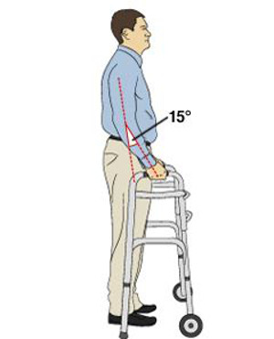

How to Walk with a Standard Walker:
While looking forward (not down), lift the walker and advance the walker an arm’s length distance. Not so far that your torso is bent over. Try to keep your body centered left to right inside the walker. There should also always be space between your body and the front of the walker. If you are too far forward, you could fall forward. Push down on the walker to stabilize yourself as you advance your body forward to meet the new walker position. Repeat. If you have glides/tennis balls, you can slide the walker instead of lifting it to advance forward.

Going Up Curbs:
Get as close as possible to the curb with the walker. Then place the walker on the curb. Push down on the walker with your hands. Step up onto the curb with your stronger leg first, then the other leg.

Going Down Curbs:
Position the walker close to the curb. Place the walker onto the ground below the curb. Step down with the weaker limb first, then the other limb.

Going Up Stairs:
For stairs with a railing only. Approach the stairs and place your feet about 6 inches from the first step. Fold the walker and grip it with one hand while the other grips the rail. Lift the folded walker and place it against the back of the first step. Step up with your stronger leg, then the weaker (or injured) leg. At the top of the stairs, unfold the walker, grip the walker with both hands and advance forward.

Going Down Stairs:
For stairs with a railing only. Approach the stairs and place the walker 2 inches from the first step. Fold the walker and grip it with one hand while the other grips the rail. Lift the folded walker and place it down on the front of the first step. Step down with your weaker (or injured) leg, then the stronger leg. At the bottom of the stairs, unfold the walker, grip the walker with both hands and advance forward.

*As an alternative, you can go up or down stairs with the walker unfolded as pictured below.

REMEMBER: WITH CURBS/STAIRS – UP WITH THE GOOD (LEG), DOWN WITH THE BAD (LEG) FIRST

Sitting/Standing With a Walker:
To sit, back up until the back legs of the walker and your legs touch the chair. Feel for the chair’s arms, grab them and slowly lower yourself down. To stand, use the chair’s arms to push up. After standing, hold the walker’s handles. DO NOT pull/tilt the walker to stand up.

