17820 SE 109th Ave #102 Summerfield, FL 34491 (352) 347-3338
1800 SE 17th St #601 Ocala, FL 34471 (352) 351-0375
Email: contact@liveoakfootankle.com
Website: www.liveoakfootankle.com

Proper Crutch Technique

To Get Up From a Chair
1. Hold both crutches on your affected side
2. Slide to the edge of the chair and push down on the arm of the chair on the good side.
3. Stand up; check your balance.
4. Put crutches under your arms and press into the side of your ribs (no in the armpit!).
5. Your elbows should be slightly bent.

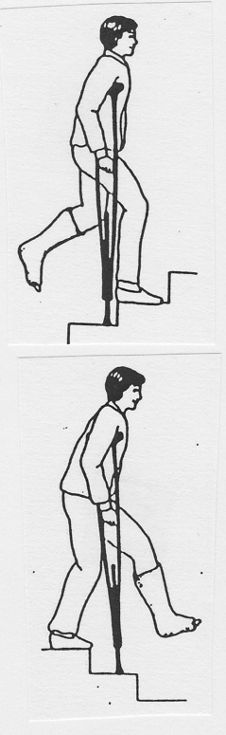
To Walk With Crutches
1. Put crutches under your arms and press into your ribs.
2. Move crutches ahead of you 6 to 12 inches.
3. Make sure to bear weight on your hands, not under your arms.
4. Check your balance before you continue.

To Sit Down in a Chair
1. Back up to the chair until you feel the chair on your legs.
2. Put both crutches in your hand on the affected side
3. Reach back for the chair with the other hand.
4. Lower yourself slowly into the chair, bending at your hips.

To Go Upstairs
1. Start close to the bottom of the step and push down through your hands.
2. Step up to the first step, remembering that the good foot goes up first.
3. Next, step up to the same step with the other foot, making sure to keep the
crutches with your affected limb.
4. Check your balance before proceeding to the next step.
5. Make sure someone is there to help if you need it.

To Go Down the Stairs
1. Start at the edge of the step, keeping your hips beneath you.
2. Slowly bring the crutches with your affected limb down to the next step (bad foot goes down first).
3. Bend at the hips and knees to prevent leaning too far forward, which could cause you to fall.
4. Check your balance before you continue.
5. Have help handy.
6. A handrail will make things easier for you. Simply hold both crutches on one side.

